**ISA Project Phase 1**

**Team Details:**

Sharath Koppu

Aravind Sheri

Harish Joshi

**1. TCP Port Scanning -**

A port scan occurs when one source IP address sends IP packets containing TCP SYN segments to 10 different destination ports within a defined interval (5000 microseconds is the default). The purpose of this attack is to scan the available services in the hopes that at least one port will respond, thus identifying a service to target.

**2. Flow Diagram –**

**TCP Scan result when port is Open**

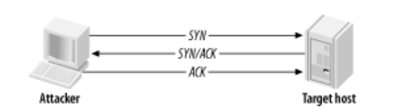

**3. Project Configurations –**

Written in **Java** language and implemented through **Eclipse Framework**

**Client** – Windows Operating Systems

**Target** – Ubuntu OS on Vmware Workstation

**Applications started in target before attacking**

Port 22 – SSH

Port 2181 - Zookeeper

Port 13562 – Mapreduce

Port 16010 – Hbase

Port 50070 – Hadoop

**Project Setup**

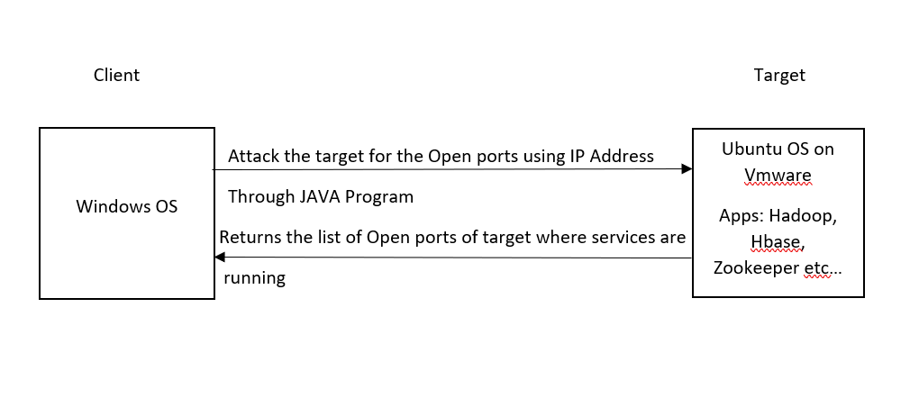

**4. Source Code –**

import java.net.*;

class TcpPortScanner {

public static void main(String []args) {

for (int port = 1; port <= 65000; port++) {

try {

Socket socket = new Socket();

socket.connect(new InetSocketAddress("192.168.157.131", port), 10);

socket.close();

System.out.println("Port " + port + " is open");

} catch (Exception ex) { }

}}

**Output –**

Port 22 is open

Port 2181 is open

Port 8030 is open

Port 8031 is open

Port 8032 is open

Port 8033 is open

Port 8040 is open

Port 8042 is open

Port 8088 is open

Port 13562 is open

Port 16010 is open

Port 16301 is open

Port 41437 is open

Port 50010 is open

Port 50020 is open

Port 50070 is open

Port 50075 is open

Port 50090 is open

**Execution –**

1. Save the code in a file with name as TcpPortScanner
2. Compile the program using javac TcpPortScanner.java
3. Run the program using java TcpPortScanner
4. Make sure that java is installed in the system
5. **Screenshots –**

**Target System -> Vmware -> Ubuntu OS**

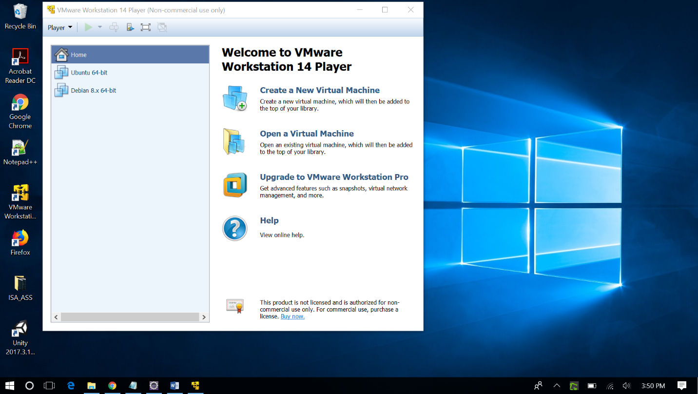

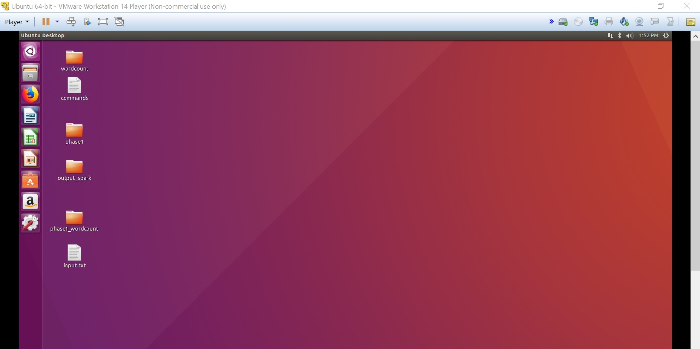

**Running the applications Hadoop, Zookeeper and Hbase in the local system**

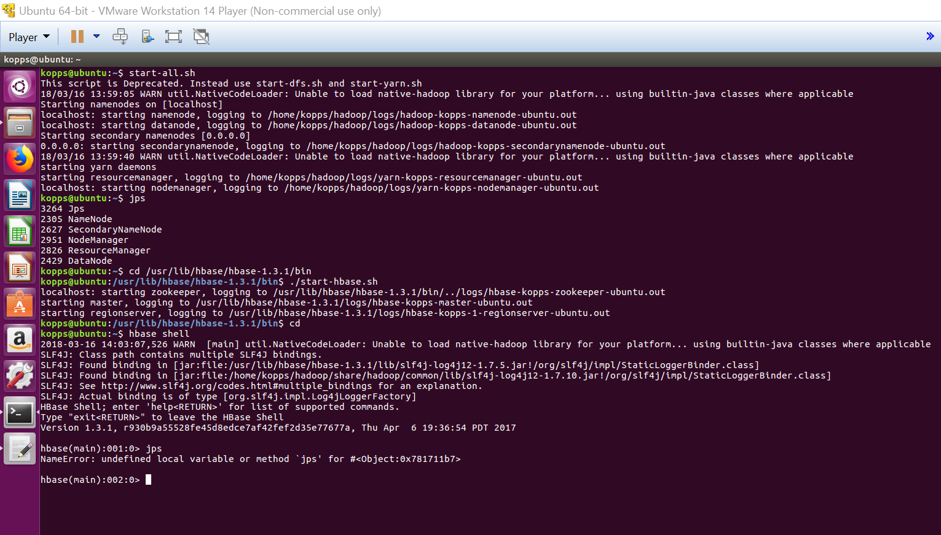

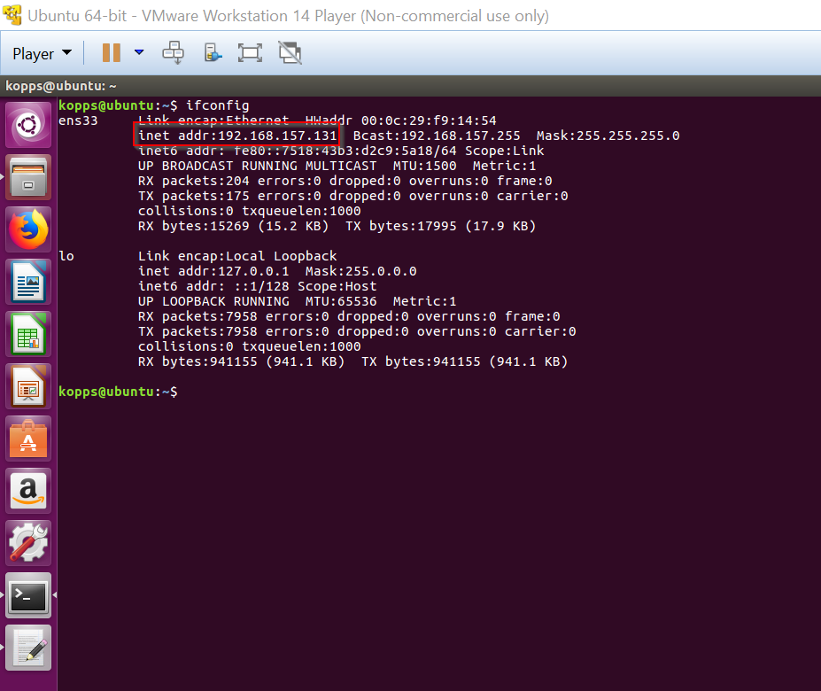

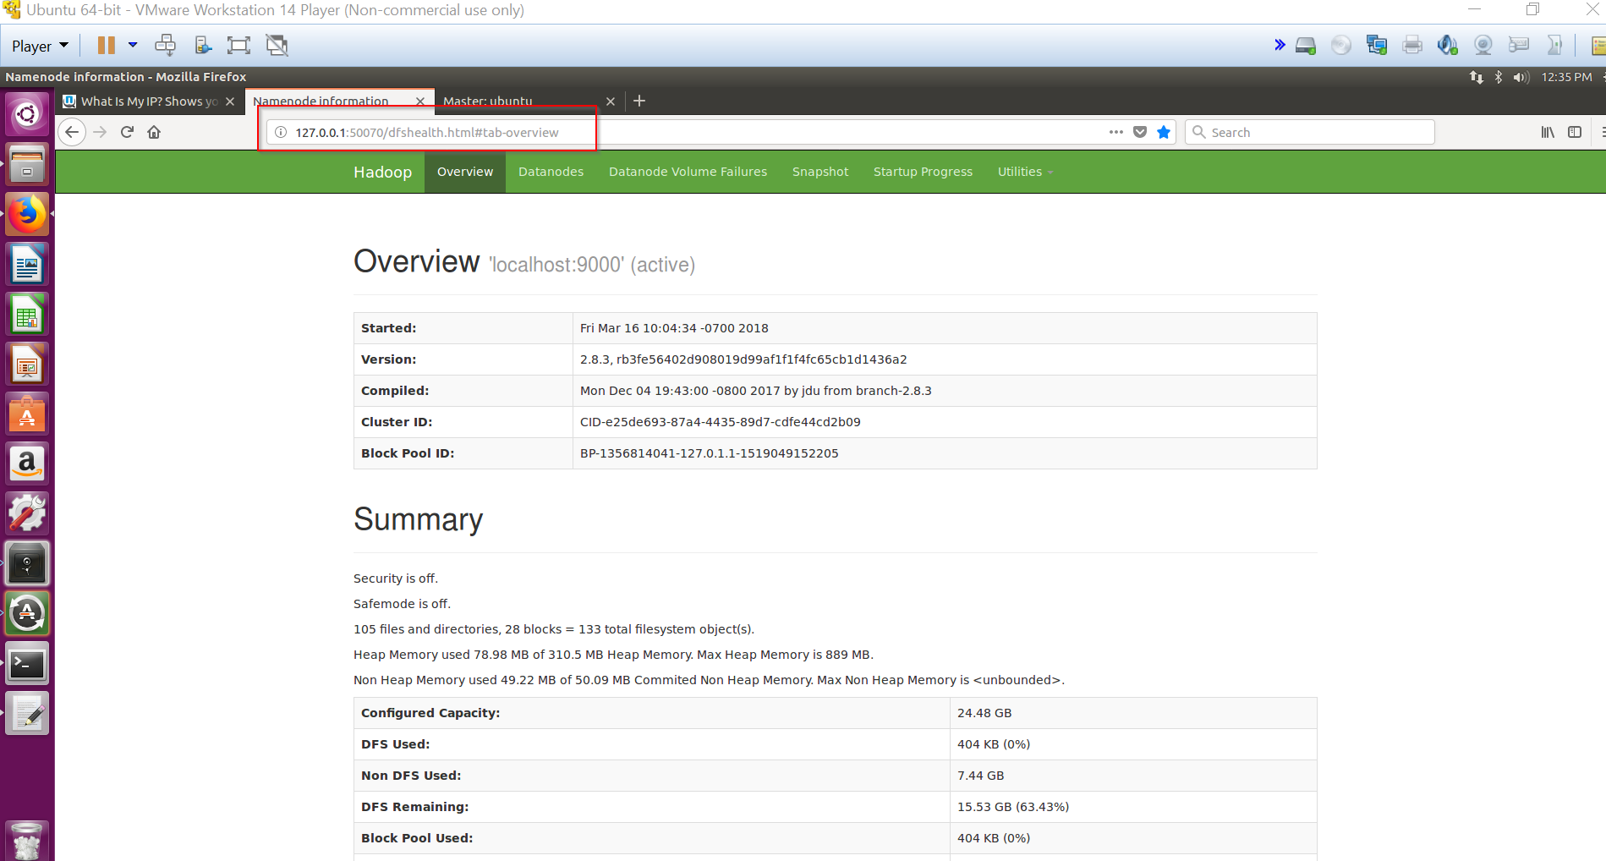

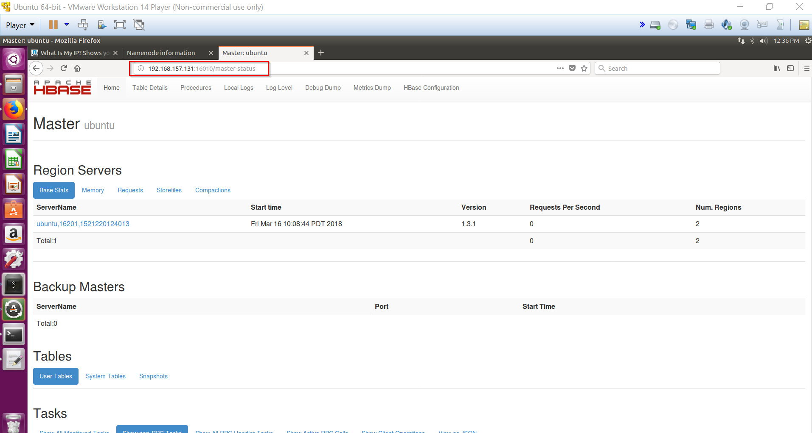

**Client System**

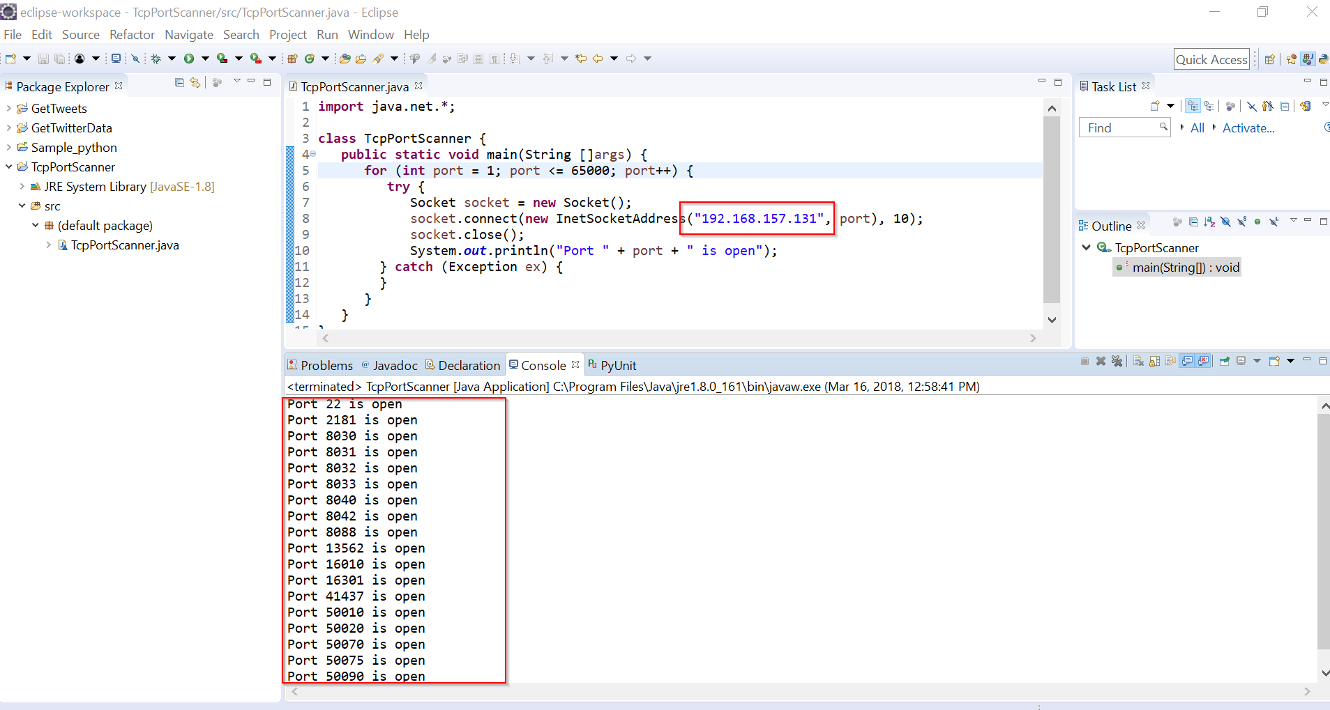

**6. References**

1. <http://etutorials.org/Networking/network+security+assessment/Chapter+4.+IP+Network+Scanning/4.2+TCP+Port+Scanning/>
2. <https://www.garykessler.net/library/is_tools_scan.html>
3. <https://stackoverflow.com/questions/1826977/get-application-server-name-or-ip-and-port-in-java>
4. <https://www.youtube.com/results?search_query=tcp+port+scanner>